**1. General CGM analysis:**

**a. What are patient expectations of CGMs? What are patient knowledge gaps with CGMs?**

Expectation keywords：

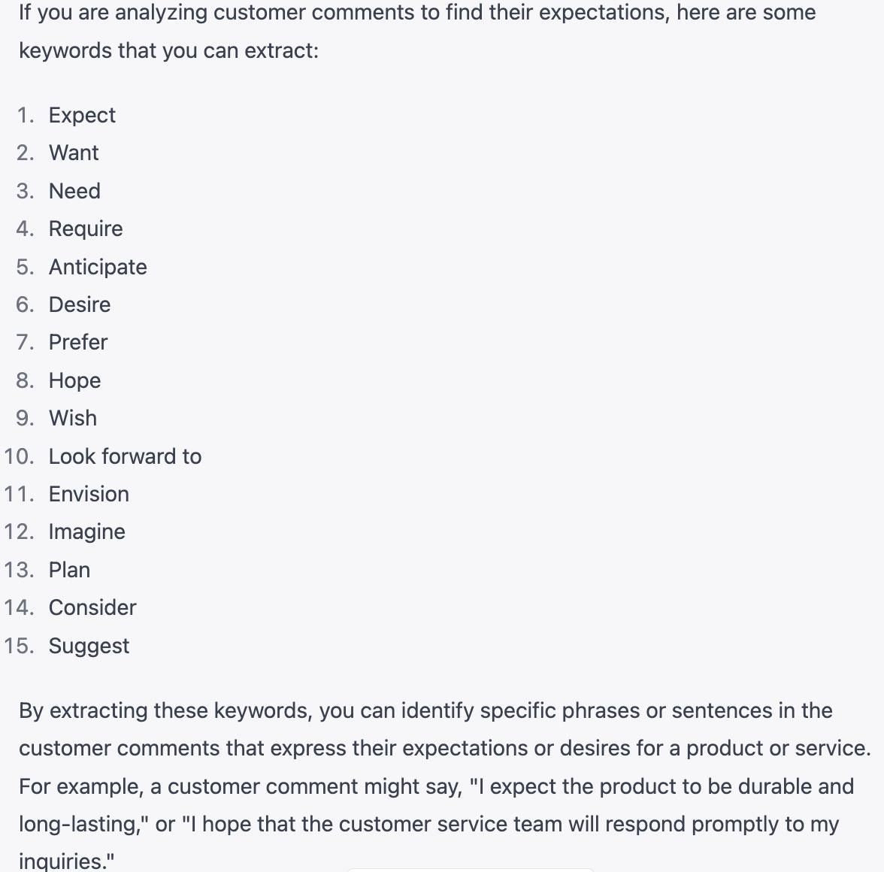

Knowledge gap keywords:

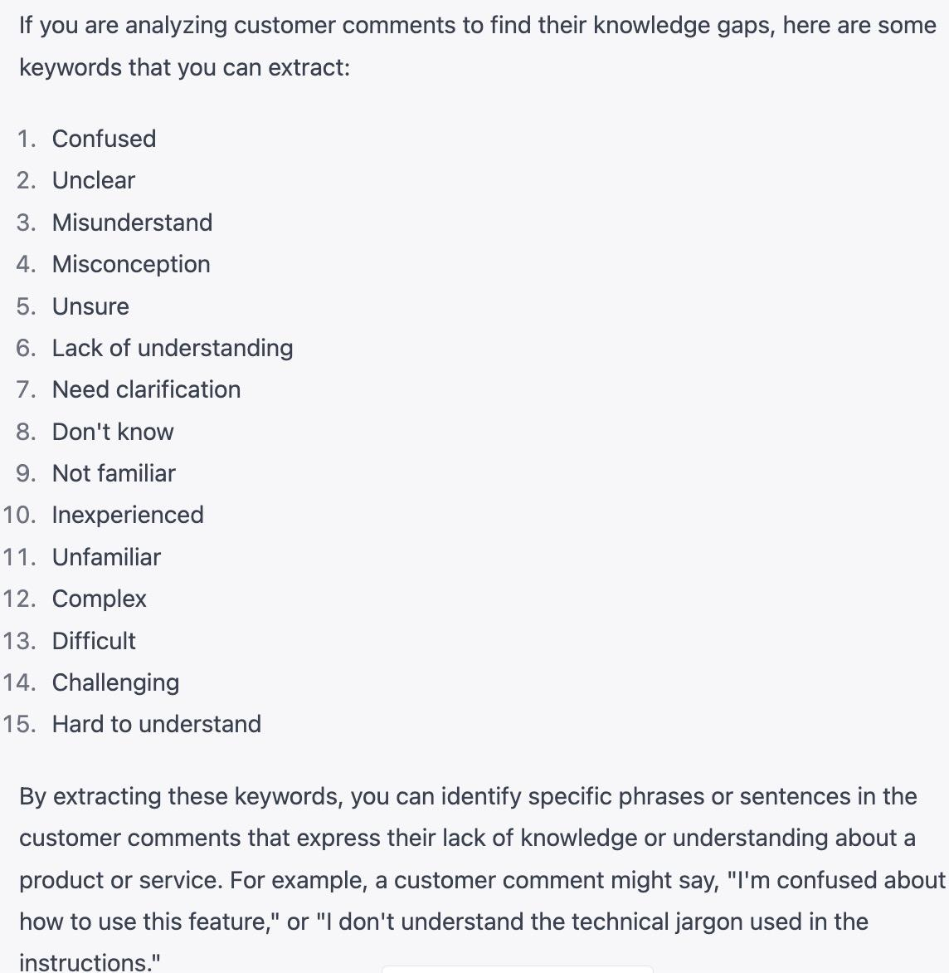

b. What benefits are most important to diabetes patients?

跟expectation有点类似吧，或许是top expectation算是most important benefits?

或者先filter positive sentimetns, 然後坐topic modeling?

c. What unmet needs do patients have related to CGMs (something patients want but are not getting)?

可以在negative sentiments里面看most frequent words

2. CGM Product-related analysis: 分成dexcom和freestyle两组

* What are praises & complaints and features of Dexcom & Freestyle Libre?

Tandem: t:slim X2 insulin pump

**Dexcom**

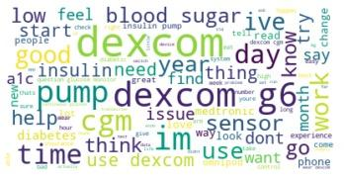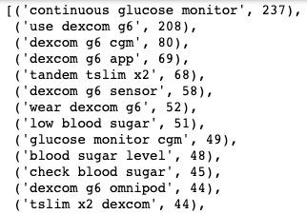

Praises: **3 words batches:** durable medical equipment; highly recommend get; make life easy; cover pharmacy benefit



**6 words batches:** 22 year battle finally feel free;good continue monitor tire abuse finger; accurate test time youve give go; app type people prefer use thank;









**8 words batches:**







Complaints:

**3 words batches: inaccurate measurement, app issues, compatible with phone versions, sensor bluetooth issue,**





Features: close loop system



* What product features are being talked about?
* How do consumer opinions of Dexcom and Freestyle Libre compare?

比较一下各自的优缺点和多少人喜欢多少人讨厌

* What is the overall sentiment regarding the two products?
* Based on your analysis, which one would you recommend?
* What would you tell each of these brands to improve?

3. **(Extra Credit)** CGM Consumer related analysis:

* Can you identify different types (segments) of consumers or create segments?
* Are different benefits more important to different consumer types?

Action Item:

1. Data cleaning - brand tagging: Dexcoms, Freestyle Libre
2. EDA

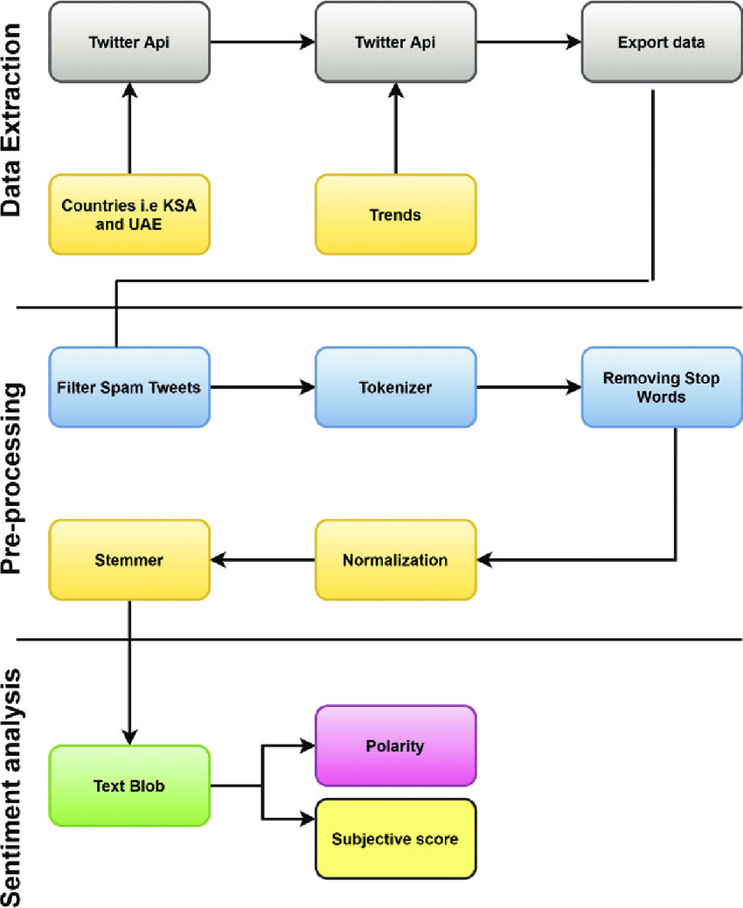

<https://realpython.com/sentiment-analysis-python/>

<https://deepnote.com/workspace/xi-yan-0621-2accb4d4-e036-4d49-84cd-676fd7c631b5/project/Untitled-project-7904fed2-d2c7-4751-9ee4-5c3ae0019c7b/notebook/Notebook%201-26bc18a3db9e457f813cb27eb2ba3a94>

Insight - Freestyle

<https://www.freestyle.abbott/us-en/products/freestyle-14-day.html>

FreeStyle Features:

1. **APP:** The FreeStyle Libre 14 day system is a continuous glucose monitoring (CGM) system consisting of the FreeStyle LibreLink app* and a glucose sensor worn on the back of the upper arm.
2. **Thin:** The sensor uses a thin, flexible filament inserted just under the skin to measure glucose levels every minute.
3. **No fingersticks required:** Use your smartphone* to scan the glucose sensor with a one-second scan to replace fingersticks.¶